**Challenge 1:** Run nmap against your localhost IP to see all open ports

* See how many of the ports you can match to services. **All of them can be match to services.**

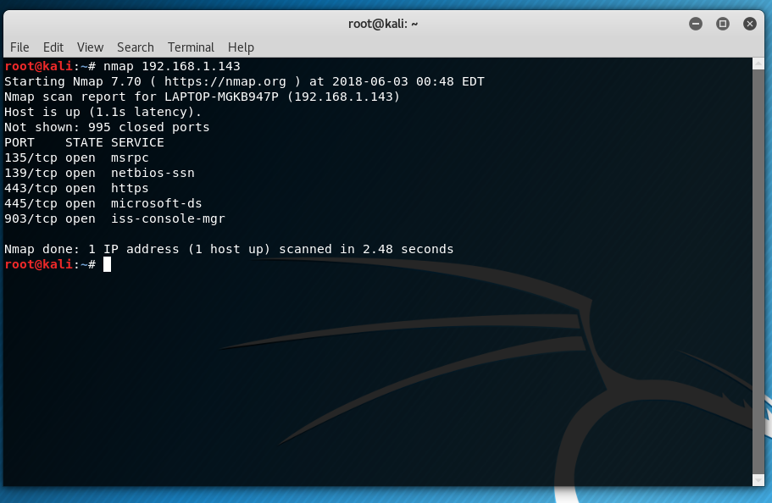

* Hint: try shutting down Docker or VirtualBox and re-running nmap.

**Stretch Challenge 2:** Map your home LAN using nmap

* If you can, **do this at home** instead of while connected to a larger network (like school or work) **Use home network.**
* Start by reading about [host discovery with nmap](https://nmap.org/book/man-host-discovery.html).
* Determine the target **IP range** from your local IP. For instance, 192.168.2.0/24 denotes the range of IPs between 192.168.2.0 through 192.168.2.255
* Read [Understanding IP Addresses, Subnets, and CIDR Notation](https://www.digitalocean.com/community/tutorials/understanding-ip-addresses-subnets-and-cidr-notation-for-networking) for more background.
* Use the stealth scan against your target IP range: sudo nmap -sP 192.168.2.1/24.



* In addition to the IPs, the manufacturer info should be displayed next to each device's MAC address. See if you can account for all the devices present: router, computers, mobile devices, printers, etc.

